ASSIGNMENT – 6 (HTML) (KASHISH)

Q-1 Create an HTML file that displays a Zomato-style restaurant card with a restaurant name, cuisine type, and rating. Use CSS to add margin, padding, and a visible border to the card so that each section is clearly separated?
Ans.
<!DOCTYPE html>
<html>
<head>
<title>Zomato Style Restaurant Card</title>
<style>
.restaurant-card {
width: 300px;
margin: 50px auto;
padding: 20px;
border: 2px solid black;
border-radius: 10px;
}
.restaurant-name {
margin-bottom: 15px;
padding: 10px;
border-bottom: 1px solid gray;
}
.cuisine {
margin-bottom: 15px;
padding: 10px;
border-bottom: 1px solid gray;
}
.rating {
padding: 10px;
border: 1px solid green;
}
</style>
</head>
<body>
<div class="restaurant-card">
<div class="restaurant-name">
<h2>Spice Villa</h2>
</div>
<div class="cuisine">
<p><b>Cuisine:</b> North Indian, Chinese</p>
</div>
<div class="rating">
<p><b>Rating:</b> 4.5 ⭐</p>
</div>
</div>
</body>
</html>

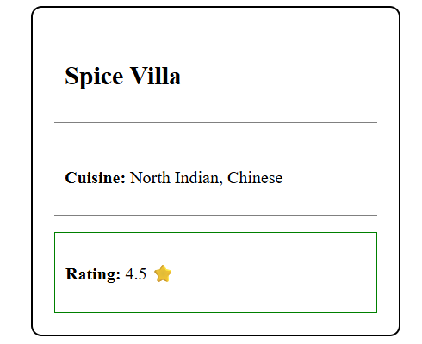

Q-2 Design a Flipkart-style product tile with an image, product name, and price. Use different display properties (block, inline-block, none) to control the layout of the product name and price, and hide the price when a specific CSS class is added.<br><br><em><strong>Hint:</strong> Try toggling the class in your HTML to see the effect.</em>?
Ans.

<!DOCTYPE html>
<html>
<head>
<title>Flipkart Style Product Tile</title>
<style>
.product-tile {
width: 250px;
border: 1px solid gray;
padding: 15px;
margin: 30px;
text-align: center;
}
/* Product image uses block display */
.product-image {
display: block;
width: 200px;
margin: auto;
}
/* Product name uses inline-block display */
.product-name {
display: inline-block;
margin-top: 15px;
padding: 5px;
}
/* Price uses block display */
.price {
display: block;
margin-top: 10px;
font-size: 20px;
font-weight: bold;
}
/* Hide the price when hide-price class is added */
.hide-price {
display: none;
}
</style>
</head>

<body>
<div class="product-tile">
<img src="wireless headphone.jpeg"
alt="Product Image"
class="product-image">
<h3 class="product-name">Wireless Headphones</h3>
<!-- Remove or add 'hide-price' to see the effect -->
<p class="price">₹2,999</p>
</div>
</body>
</html>

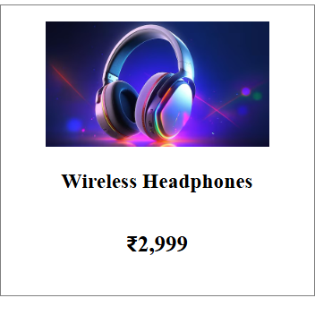
Q-3 Build a fixed-position WhatsApp chat notification badge at the bottom right corner of the screen. Use position: fixed and appropriate margin and padding to ensure it stays visible even when scrolling?
Ans.
<!DOCTYPE html>
<html lang="en">
<head>
<meta charset="UTF-8">
<meta name="viewport" content="width=device-width, initial-scale=1.0">
<title>WhatsApp Notification Badge</title>

<style>
body {
font-family: Arial, sans-serif;
height: 1500px;
margin: 0;
padding: 20px;
background-color: #f5f5f5;
}
/* WhatsApp Chat Badge */
.whatsapp-badge {
position: fixed;
bottom: 25px;
right: 25px;
background-color: #25D366;
color: white;
padding: 15px 20px;
margin: 10px;
border-radius: 30px;
text-decoration: none;
font-size: 16px;
font-weight: bold;
box-shadow: 0 4px 10px rgba(0, 0, 0, 0.3);
}
.whatsapp-badge:hover {
background-color: #128C7E;
}
/* Notification Number */
.notification {
background-color: red;
color: white;
font-size: 12px;
padding: 4px 7px;
border-radius: 50%;
position: absolute;
top: -8px;
right: -8px;
}
</style>
</head>
<body>\
<h1>My Website</h1>
<p>Scroll the page and the WhatsApp badge will remain visible.</p>
<p>
This is some extra content to demonstrate scrolling.
Keep scrolling down and check the bottom-right corner.
</p>
<!-- WhatsApp Badge -->
<a href="#" class="whatsapp-badge">
💬 WhatsApp
<span class="notification">10</span>
</a>
</body>
</html>

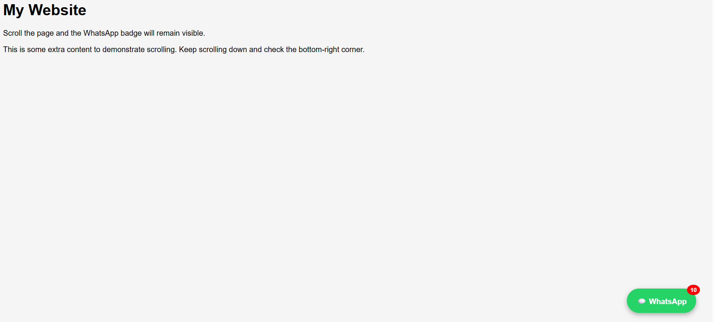

Q-4 Create a BookMyShow movie poster grid where each poster uses position: relative. Add a 'New' badge to the top-left corner of one poster using position: absolute, so it overlays the image correctly.<br><br><em><strong>Hint:</strong> Use top and left properties with position: absolute inside a relatively positioned parent.</em>?
Ans.
<!DOCTYPE html>
<html lang="en">
<head>
<meta charset="UTF-8">
<meta name="viewport" content="width=device-width, initial-scale=1.0">
<title>BookMyShow Movie Grid</title>

<style>
* {
margin: 0;
padding: 0;
box-sizing: border-box;
}
body {
font-family: Arial, sans-serif;
background-color: #f5f5f5;
}
h1 {
text-align: center;
margin: 30px 0;
color: #333;
}
.movie-grid {
width: 90%;
margin: auto;
display: grid;
grid-template-columns: repeat(4, 1fr);
gap: 25px;
}
/* Movie poster container */
.movie {
position: relative;
background-color: white;
border-radius: 10px;
overflow: hidden;
box-shadow: 0 4px 10px rgba(0, 0, 0, 0.15);
}
.movie img {
width: 100%;
height: 350px;
object-fit: cover;
display: block;
}
.movie h3 {
padding: 12px;
text-align: center;
color: #333;
}
/* New badge */
.new-badge {
position: absolute;
top: 10px;
left: 10px;
background-color: #e23744;
color: white;
padding: 6px 12px;
border-radius: 5px;
font-size: 14px;
font-weight: bold;
}
/* Responsive design */
@media (max-width: 900px) {
.movie-grid {
grid-template-columns: repeat(2, 1fr);
}
}
@media (max-width: 500px) {
.movie-grid {
grid-template-columns: 1fr;
}
}
</style>
</head>
<body>
<h1>🎬 BookMyShow Movies</h1>
<div class="movie-grid">
<!-- Movie 1 -->
<div class="movie">
<span class="new-badge">New</span>
<img src="cartoon movie.jpg"
alt="kids movie">
<h3>Avengers</h3>
</div>
<!-- Movie 2 -->
<div class="movie">
<img src="mr bean.jpg"
alt="Mr bean ">
<h3>Movie Night</h3>
</div>
<!-- Movie 3 -->
<div class="movie">
<img src="kerela story.jpg"
alt="Kerela story">
<h3>real life story</h3>
</div>
<!-- Movie 4 -->
<div class="movie">
<img src="total dhamaal.jpg"
alt="Total dhamaal">
<h3>comedy movie</h3>
</div>
</div>
</body>
</html>

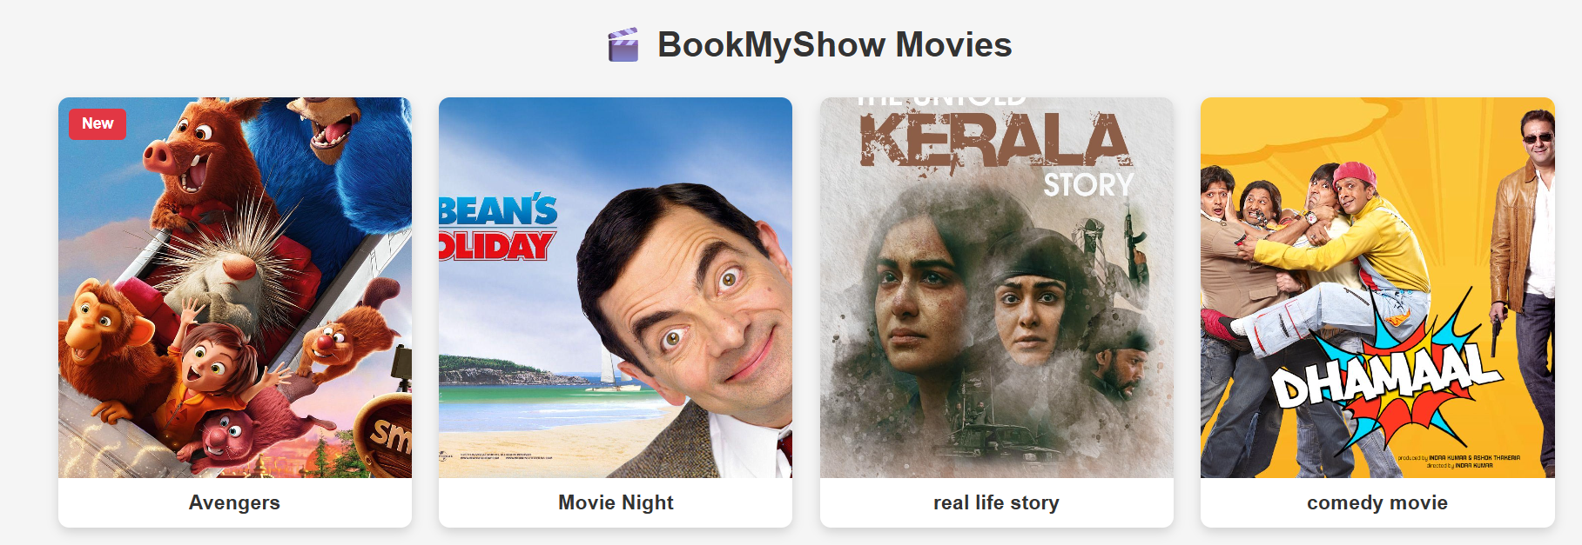
Q-5 Refactor your CSS for any one of the above tasks to reduce repeated margin and padding values by using a reusable CSS class. Explain in a comment how this improves maintainability?
Ans.
<!DOCTYPE html>
<html>
<head>
<title>BookMyShow Movie Posters</title>

<style>
/* Reusable spacing class
Using one class reduces repeated margin/padding values,
making the CSS easier to maintain and update. */
.spacing {
margin: 10px;
padding: 10px;
}
.movie-grid {
display: flex;
gap: 20px;
justify-content: center;
}
.movie-poster {
position: relative;
width: 200px;
border: 1px solid #ccc;
}
.movie-poster img {
width: 100%;
height: 280px;
object-fit: cover;
}
.new-badge {
position: absolute;
top: 10px;
left: 10px;
background-color: #e51c23;
color: white;
border-radius: 5px;
font-weight: bold;
}
.movie-title {
text-align: center;
font-weight: bold;
}
</style>
</head>
<body>

<h1>Recommended Movies</h1>
<div class="movie-grid">

<div class="movie-grid">
<div class="movie-poster">
<img src="kerela story.jpg" alt="kerela story">
<span class="new-badge spacing">NEW</span>
<div class="movie-title spacing">Real life story</div>
</div>
<div class="movie-poster">
<img src="total dhamaal.jpg" alt="Total dhamaal">
<div class="movie-title spacing">Comedy movie</div>
</div
</div>
</body>
</html>

